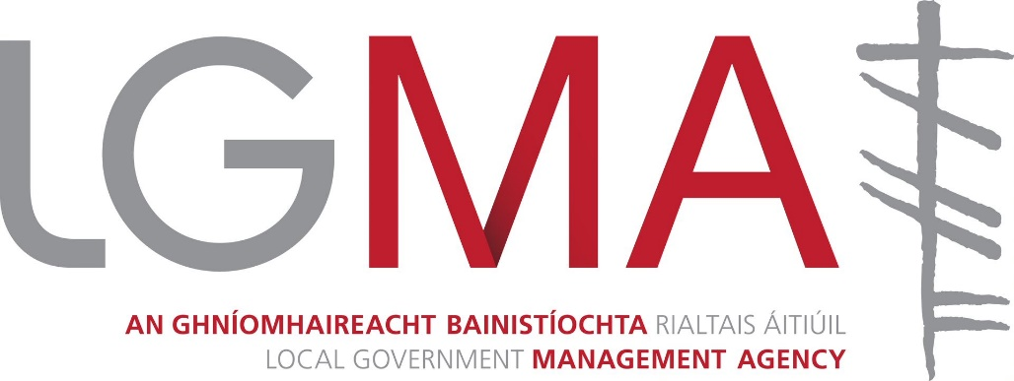

Application form for the post of
Business Analyst, Grade 7

Please submit applications by 5.00pm on 13th March 2020 to: jobapplications@lgma.ie

Typed Format Only

Section A: Personal Details

Name
Address
Telephone
Email

Section B: Education and Professional Qualifications
Please provide full details of all your relevant educational, professional, training and development experience in the sections below.
Full title of degree/qualification(s) held | Grade obtained, e.g. 2.2; 2.1; 1; etc. | Subjects in final exam | Year in which Degree / Qualification was obtained | University, College or Examining Authority

Other formal Education/Training/Development
Full title of qualification(s) held | Years attended  from-to | Training Body

Membership of professional associations, institutions, etc. (if appropriate)

Section C: Employment Record
Please provide details of the context and main responsibilities of your last four roles commencing with current role. Experience prior to these should be entered on the ‘career summary’ section.
Name/Address of employer
Title of Post
Dates (from-to)
Number of staff reporting to you
Description of main responsibilities

Name/Address of employer
Title of Post
Dates (from-to)
Number of staff reporting to you
Description of main responsibilities
Name/Address of employer
Title of Post
Dates (from-to)
Number of staff reporting to you
Description of main responsibilities

Name/Address of employer
Title of Post
Dates (from-to)
Number of staff reporting to you
Description of main responsibilities

Brief summary of previous employment experience
Date(s)  from-to | Title | Nature of Work | Employer

Section D: Job Specific Competencies
Using the spaces below, for each of the areas of competence, please briefly highlight specific achievements, contributions or expertise you have developed, from your career to date, which clearly demonstrates your suitability to meet the challenges at this level.
Do not exceed 200 words per competency.
Management and Change
(Areas where examples could be given would include Bringing About Change, Influencing and Negotiating)

Delivering Results
(Areas where examples can be given would include Operational Planning, Delivering Quality Outcomes)

Personal Performance
(Areas where examples can be given would include Leading and Motivating, Communicating Effectively)

Personal Effectiveness
(Areas where examples could be given would include Qualifications and Knowledge, Personal Motivation, Initiative and Achievement)

Section E: Other Information
Please specify what other experience, involvements and/or special qualities you have which you feel equip you for this position in the Local Government Management Agency

Section F: Particulars of Referees
Please give details of those from whom assessments as to your suitability for the post may be sought
Name | Position or occupation | Address | Email/Phone

Section G: Additional Information
- Do you require an employment permit/visa to work in Ireland?
Yes ☐
No ☐
If yes, please state date of expiry

Please note that any offer of employment will be conditional upon the individual being legally entitled to live and work in Ireland.

- We require the following information to enable us to provide for any needs you may have should you be called for any stage of this competition, e.g. Sign Language.
- Do you consider that you have a disability
Yes ☐
No ☐
- If yes, please give details of your requirements, if any, to enable us to make appropriate arrangements for this competition.
_______

- Knowledge of Irish
Good ☐
Fair ☐
Not good ☐

Please note: ‘Good’ means being capable of performing the duties of office though the medium of Irish.

- For record purposes, do you have a current valid driving licence?
Yes ☐
No ☐
- If Yes, please state if Full or Provisional
- Please state category of vehicles covered

- Have you ever accepted Voluntary Redundancy/Early Retirement from a Local Authority or other public service organisation by which you were employed?
Yes ☐
No ☐
If yes, please give details of grade/post retired/resigned from

Declaration
I, hereby declare, that all particulars in this application are true and correct, to the best of my knowledge and belief. I give my permission for enquiries to be made to establish such matters as age, qualifications, experience and character and for the release by other people or organisations of such information as may be necessary to the LGMA for that purpose. This may include enquiries from past/present employers and the submission of this application is taken as consent to this. I am aware that any canvassing, by me, or on my behalf, will disqualify me from the position I am seeking and that any employment offered to me is dependent upon the information given herein being correct. I am aware that false or misleading information or deliberate omissions may result in termination of any employment offered.

Signature of applicant _

Date

The Local Government Management Agency is an equal opportunities employer.
The information supplied in this form is held on the understanding of confidence subject to the requirements of the Freedom of Information Act 2014 or other legal requirements.

